Qno.1 Write a program to print your name in Dart.
void main()
{ var name = "Nisma\tPaudel";
print(name);
}
Outout:

Qno.2 Write a program to print Hello I am “John Doe” and Hello I’am “John Doe” with single and double quotes.
void main(){
var firstName = "John";
var lastName = "Doe";
print("Hello I am "'"$firstName $lastName"');
print("Hello I'am $firstName $lastName");

}
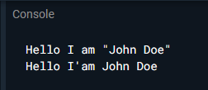
Qno.3 Declare constant type of int set value 7.
void main(){
const type = 7;
print("Value of type is $type");
}
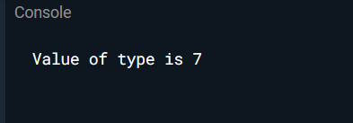
void main(){
const type = 7;
type = 4; // not possible
print("Value of type is $type");
}
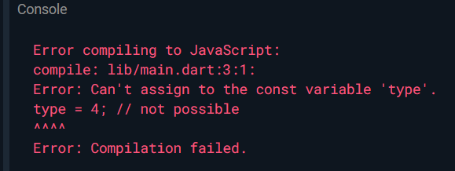
Qno.4 Write a program in Dart that finds simple interest. Formula= (p * t * r) / 100
void main() {
double principle=400;
double rate= 2.8;
int time =2;
double SI=(principle*rate*time)/100;
print("The simple interest is $SI");
}
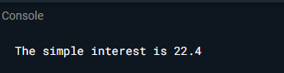
Qno.5 Write a program to print a square of a number using user input.
import 'dart:io';
void main() {
print("Enter a no.to find it's square");
int num = int.parse(stdin.readLineSync()!);
int sq=num*num;
print("The square of a number is $sq");
}
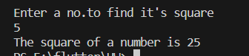
Qno.6 Write a program to print full name of a from first name and last name using user input.
import 'dart:io';
void main() {
print("Enter first name:");
String? firstname = stdin.readLineSync();
print("Enter last name:");
String? lastname = stdin.readLineSync();
print("The Full name is $firstname ${lastname}");
}
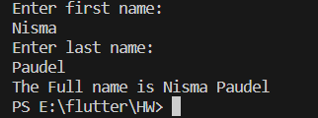

Qno.7 Write a program to find quotient and remainder of two integers.
void main()
{
int num1=36;
int num2=6;
num quotient=num1/num2;
num remainder=num1%num2;
print("the quotient is $quotient");
print("the remainder is $remainder");

}
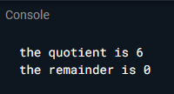

Qno.8 Write a program to swap two numbers.
void main() {
int num1 = 5;
int num2 = 10;
print("Before swapping: num1 = $num1, num2 = $num2");
int temp = num1;
num1 = num2;
num2 = temp;
print("After swapping: num1 = $num1, num2 = $num2");}
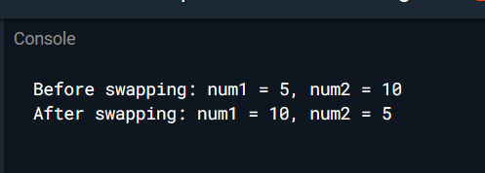
Qno.9 Write a program in Dart to remove all whitespaces from String.
void main() {
String value = " Nisma Paudel ";
print ("Before trimming ($value) ");
print ("After Trimming (${value.trim()}"));
}
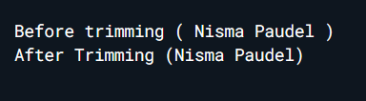
Qno.10
void main() {
String st1 = "5";
print("Type of st1 is ${st1.runtimeType}");
int num1 = int.parse(st1);
print("Value of num1 is $num1");
print("Type of num1 is ${num1.runtimeType}");
}
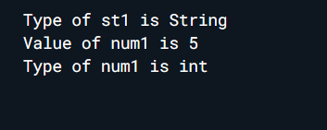

Qno.11
import 'dart:io';
void main() {
print ("Enter the number of People");
int numberOfPeople = int.parse(stdin.readLineSync()!);
print ("Enter the amount");
double totalBillAmount = double.parse(stdin.readLineSync()!);
double formula= (totalBillAmount) /( numberOfPeople);
print("The Equal amount of money is $formula");
}
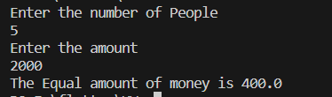
Qno.12
void main() {
double distance = 25;
double speed = 40;
double timeInHr = distance / speed;
int timeInMin = (timeInHr * 60).round();
print("Time taken to reach office: $timeInMin minutes");
}
